**1.1 ABOUT THE PROJECT**

An Online Eye Hospital Management System is a software application that is implemented by hospitals to allow guests to create secure online appointments. The Eye Hospital Management system can be synced, not only with your current website but also with Facebook. This allows patients to book appointments in a way that is convenient for them via social media.

An Online Eye Hospital Management system is a necessity for today’s accommodation providers, both large and small. An increasing number of patients are relying solely on online appointments to book their accommodations, and without this capability, you will lose a significant amount of business.

This type of software iskey to having global appeal and to increased occupancy rates. It’s an essential tool to increase appointments, and create enhanced guest experiences, leading to higher patient retention and increased revenue.

A Management system improves efficiency for hospitals**,** primarily because availability is updated immediately across all channels, including your system. This reduces the amount of time needed for the front desk to dedicate to administrative tasks and also minimizes the risk of overbooking.

Furthermore, an online booking system can automate tasks like sending out booking confirmations so that staff can spend their time taking care of other important areas like providing top-notch patient service. Since patients are essentially in charge of generating their own appointment bookings arrive in the system with all the necessary information already in place – all the reception staff has to do is get ready for their arrival.

**2.1 SYSTEM STUDY**

In this modern world of gadgets, where every service is getting digitalized, everyone prefers convenience over cost. Our Eye Hospital Management System is a system intended to provide the best services to its users at the cheapest possible cost.

System study refers to the process of examining a situation with the intent of improving it through better processes and methods. System study is, therefore, the process of gathering and interpreting facts, diagnosing problems, and using the information to recommend changes in the system, in other words, it means a detailed explanation or description. Before computerizing a system under consideration, it must be analyzed. We need to study how it functions currently, what are its problems, and what requirements the proposed software should meet.

The main components of making software are:

* System and software requirement analysis
* Design and implementation of software
* Ensuring, verifying, and maintaining software integrity

**2.1.1. Existing System**

The existing system is not very convenient as the patient has to spend a lot of time and resources. It is a tedious and time-consuming process. The existing system was manual. And it was found to be inefficient in meeting the growing demands of the population. There are also frequent chances of data redundancy and data is easy to lose.

**2.1.2. Proposed System**

The objectives of the proposed system are to overcome the major limitation of an existing system enabling effective management of patient details thereby improving the performance of shop administration. The Eye Hospital Management system is a suitable one.

The patient can log into the website and explore the different types of rooms available. For the ease of patient, the website can be accessed 24*7. It is more efficient and reliable than the existing system. This system understands the needs of the patient

Advantages of the Proposed System:

· The new system would easily overcome most of the shortcomings of the current system.

· Owner can see the fine report.

· Not much manual work is involved.

· Ensure data accuracy

· Security of data is done.

· Save a lot of time and effort.

· Optimize processing time.

· User-friendly system.

**2.1.3. Feasibility Study**

The feasibility study is made to see if the project on completion will serve the purpose of the organization for the amount of work, time, and effort spent on it.

The study lets the developer foresee the future of the project and its usefulness. Finding out whether a new system is required or not.

The study is carried out to the best system that meets the performance requirement. This entails identification, description, and evaluation of the candidate system and selection of the best system for the job. It simply identifies whether the proposed system is feasible for the organization or not.

There are three aspects in the feasibility study portion of the preliminary investigation

* Technical feasibility
* Economic feasibility
* Operational feasibility

**2.1.3.1. Technical Feasibility**

The system must be evaluated from a technical viewpoint first. The assessment of this feasibility must be based on an outline design of the system requirement in the terms of input, output, programs, and procedure having identified an outline system, the investigation must go on to suggest the type of equipment, required method of developing the system, method of running the system once it has been designed. The project should be developed such that the necessary functions and performance are achieved within the constraints. The project is developed with the latest technology.

There are only minimal constraints involved in this project.

**2.1.3.2. Economic Feasibility**

Here is an evaluation of development cost weighted against the ultimate income or benefit derived from the developed system. The cost for the development of the project has been evaluated and we want to check that the cost does not exceed the beneficial cost of the system. The economic and financial analysis is used for evaluating the effectiveness of the candidate system. This project underwent economic feasibility study and found that it is feasible. So, the cost of development does not exceed its beneficial cost. This brought to the conclusion that the system is economically feasible in the context.

**2.1.3.3. Operational Feasibility**

In operational feasibility, the entire application is checked whether the system will be used if it is developed and implemented. Also, it is checked whether there will be resistance from the users that may undermine the possible application benefits. There is no barrier to implementing the system. The system also helps to access the information immediately as the need arises. Thus, the system is found to be operationally feasible.

## 2.2 USER CHARACTERISTICS

**The system has three users:**

**2.2.1 Administrator**

**2.2.2 Doctor**

**2.2.3 Staff**

**2.2.4 Patient**

**2.2.1 Administrator**

The administrator or admin has all privileges on every process performed in the system.

Admin can add, edit or view the details of staff and doctors. He/ She can manage staff, doctors, patients, bookings, and payments.

**2.2.2 Doctor**

Doctors can use the system to check his/her bookings and view their respective patient details. The administrator is responsible for managing the details of his doctor. He/ She can view patients and their concerned details.

**2.2.3 Staff**

The staff has fewer privileges than the admin but has more privileges as compared to the patients. The administrator is responsible for managing the details of his staff. Staff can view the availability of doctors. He/ She can view patients, bookings, and payments

**2.2.4 Patient**

The patient can only use the system to book the rooms and add make payments for the respective appointments using debit cards. The patient later can view their booked appointments. The patient logs into the system by registering himself. He/she can also make payments directly.

**2.3 SYSTEM SPECIFICATION**

**2.3.1 Hardware Specification**

The selection of hardware is very important for the existence and proper working of any software. When selecting the hardware, the size and capacity requirements are also noted. Below are the hardware details required by the system.

|  |  |
| --- | --- |
| Processor | Intel Core i5-3220 (3.3 GHz) or above |
| RAM | 4 GB |
| Storage | 512 GB and above |
| Key Board | Normal or multimedia |
| Monitor | 15’’CRT or LCD monitor |
| Mouse | Compatible Mouse |

**2.3.2 Software Specification**

|  |  |
| --- | --- |
| Operating System | Windows 7/8/8.1/10 |
| Front End | PYTHON |
| Back End | MySQL |

**2.3.3 About the Software Tools and Platform**

**FRONT END SPECIFICATION: PYTHON**

Python is a high-level general-purpose programming language. Guido van Rossum began working on Python in the late 1980s, as a successor to the ABC programming language, and first released it in 1991 as Python

0.9.0. Its design philosophy emphasizes code readability with the use of significant indentation. Its language constructs and object-oriented approach aim to help programmers write clear, logical code for small- and large-scale projects.

Features:

One of the key features of python is Object-Oriented programming.

Graphical User interfaces can be made using a module such as PyQt5, PyQt4, wx Python, or Tk in python.

Python is an Interpreted Language because Python code is executed line by line at a time.

**BACKEND SPECIFICATION: MYSQL**

A database is a separate application that stores a collection of data. Each database has one or more distinct APIs for creating, accessing, managing, searching and replicating the data it holds.

Other kinds of data stores can also be used, such as files on the file system or large hash tables in memory but data fetching and writing would not be so fast and easy with those type of systems.

Nowadays, we use relational database management systems (RDBMS) to store and manage huge volume of data. This is called relational database because all the data is stored into different tables and relations are established using primary keys or other keys known as Foreign Keys.

## 3.1 MODULES & DESCRIPTION

The Online Eye Hospital Management system provides us with various facilities to manage the activities taking place in the system. This system is developed to manage the bookings done in the hospital. There are 6 modules in this project:

## 1. DOCTOR MANAGEMENT

This Module helps us to manage the staff of the system. In this module admin and staff can perform tasks such as adding doctors, editing doctor’s details, and searching for a particular doctor’s detail. This module is directly managed by the admin and staff.

## 2. STAFF MANAGEMENT

This Module helps us to manage the staff of the system. In this module, the admin can perform tasks such as adding staff, editing staff details, and searching for a particular staff detail. This module is directly managed by the Admin.

## 3. PATIENT REGISTRATION

In this module, we collect the details of the patient. The patient himself can register into the system. If further needed, the patient can edit their details and also display the same.

## 4. APPOINTMENT MANAGEMENT

In this module, we can book the appointment as per the patient’s needs. Patients can choose different types of appointments if required. They have the provision to edit the booking from the cart page. Admin displays the details of the booking.

## 5. PAYMENT MANAGEMENT

In this module, we manage the payment made by the patient. The appointment is booked after the payment completion. If the user makes the payment online, it is done by using a debit card.

**6. CANCELLATION MANAGEMENT**

In this module, patients can cancel their appointment**.** if a patient wants to cancel an appointment, he/she can do that easily and can receive a refund. Cancellation can be done within 3 days after booking an appointment

### 3.2. DATA FLOW DIAGRAM

A data flow diagram is a graphical tool used to describe and analyze the movement of data through a system. These are a central tools and the basis from which the other components are developed. The transformation of data from input to output, through processing, may be described logically and independently of physical components associated with the system. These are known as the logical data flow movement of data between people, departments, and workstations. A full description of a system actually consists of a set of data flow diagrams.

A DFD also known as a “bubble chart” has the purpose of clarifying system requirements and identifying major transformations that will become programs in system design. So, it is the starting point of the design to the lowest level of detail. A DFD consists of a series of bubbles joined by data flows in the system.

In the DFD, there are four symbols

The process that transforms data flow

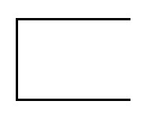Source or Destination of data

Data Store

Information or Dataline

### Rules for drawing data flow diagrams

Rule 1: Establish the context of the data flow diagram by identifying all of the net input and output data flows.

Rule 2: Select a starting point for drawing the DFD.

Rule 3: Give meaningful labels to all data flow lines.

Rule 4: Label all processes with action verbs that relate input and output data flows.

Rule 5: Omit insignificant functions routinely handled in the programming process.

Rule 6: Do not include control or flow of control information.

Rule 7: Do not try to put too much information in one DFD.

Rule 8: Be prepared to start over.

### Level 0 DFD Showing Online Eye Hospital Management System

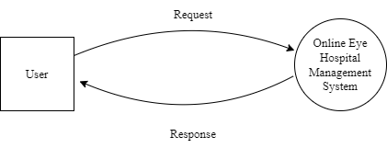

### Level 1 DFD Showing Online Eye Hospital Management System

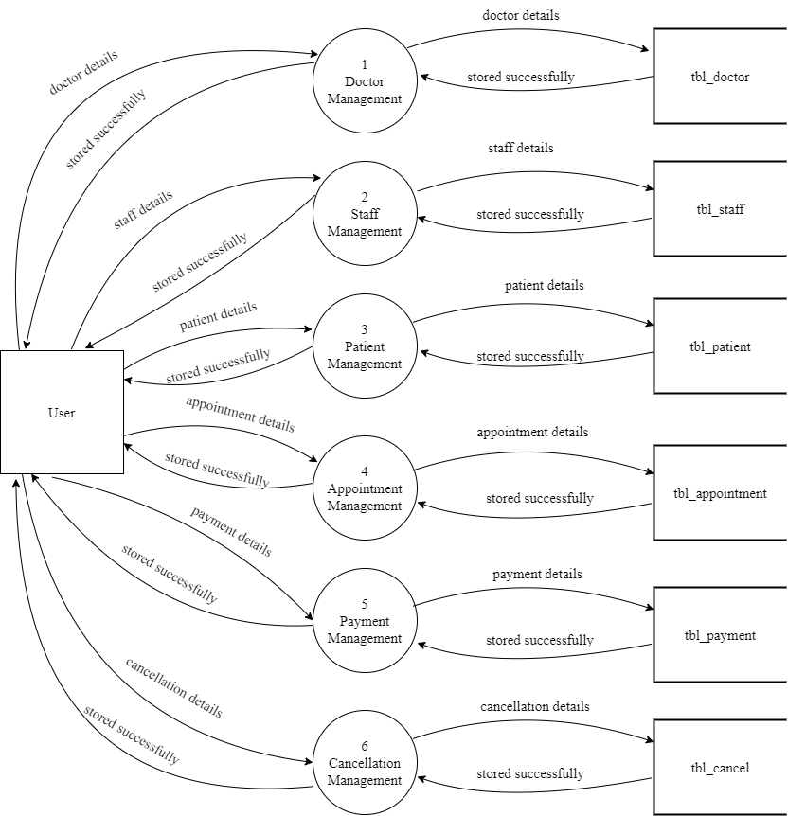

**Level 2 DFD Showing Doctor Management**

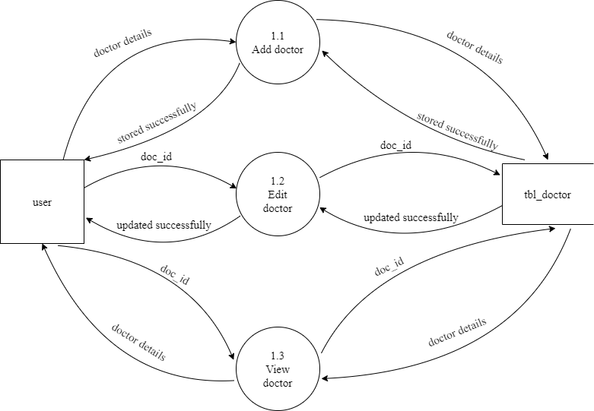

**Level 2 DFD Showing Staff Management**

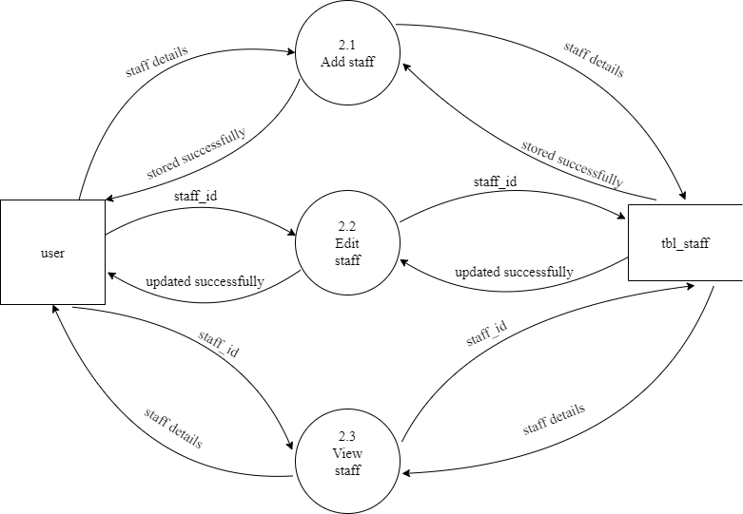

**Level 2 DFD Showing Patient Registration**

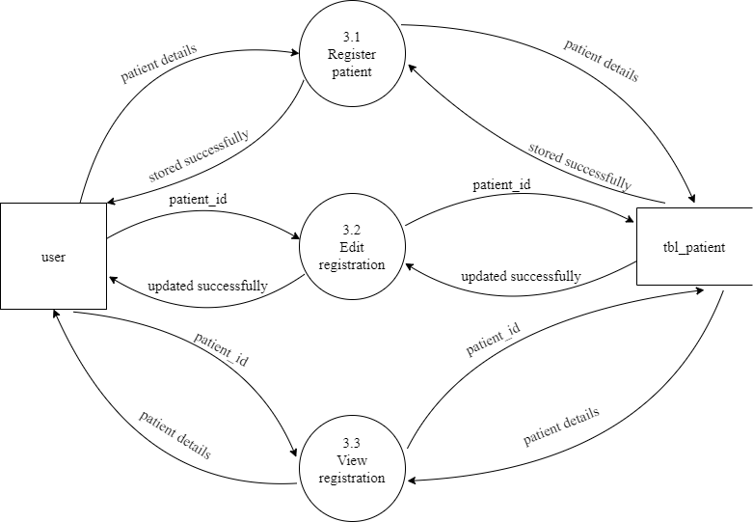

### Level 2 DFD Showing Appointment Management

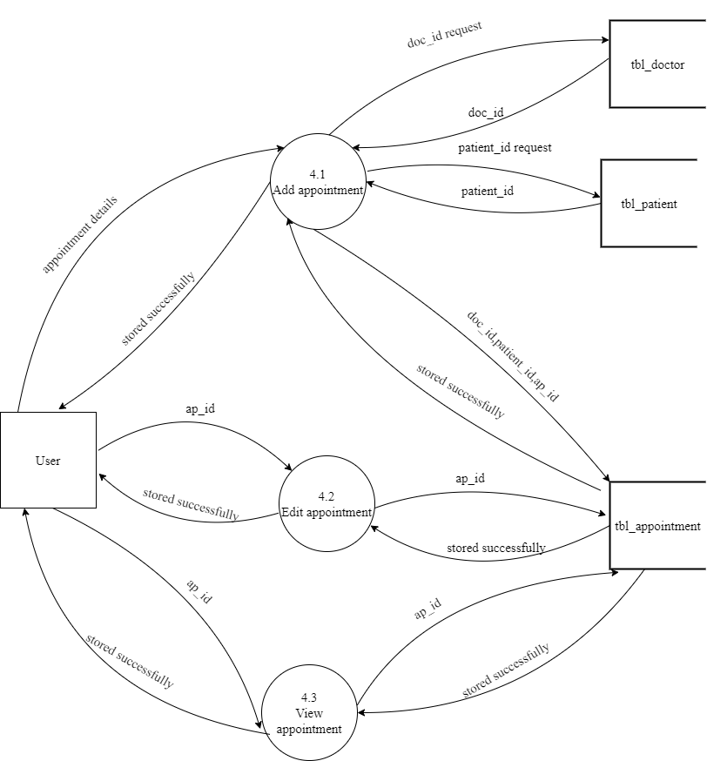

**Level 2 DFD Showing Payment Management**

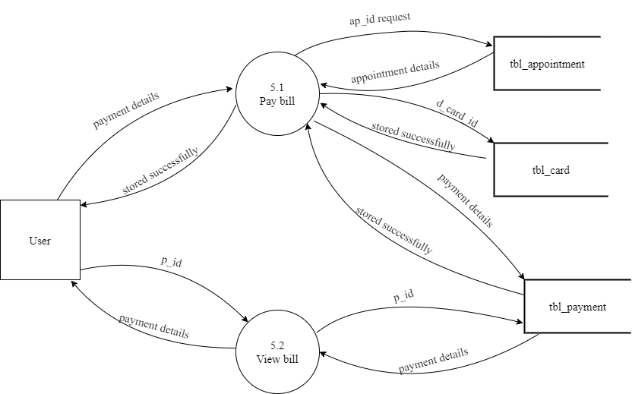

**Level 2 DFD Showing Cancellation Management**

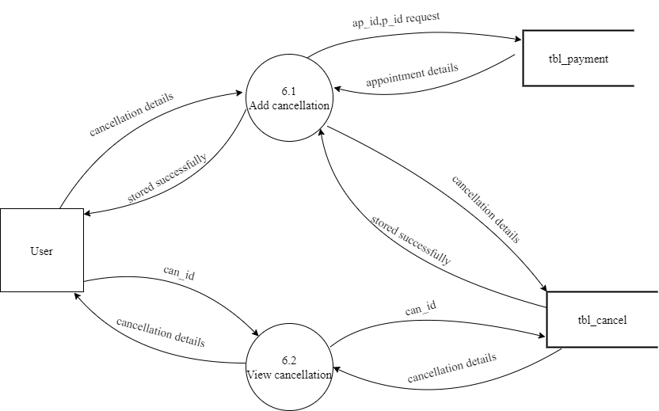

**3.3 ENTITY RELATIONSHIP DIAGRAM**

The ER model is a conceptual data model that views the real world as a construct of entities and associations or relationships between entities. A basic component of the model is the Entity-Relationship diagram, which is used to visually represent data objects. The ER modeling technique is frequently used for the conceptual design of database applications and many database applications and many database design tools employ its concepts.

Entity Type

Weak Entity Type

Relationship Type

Attribute

Key Attribute

Multivalued Attribute

**ER Diagram Showing Online Eye Hospital Management System**

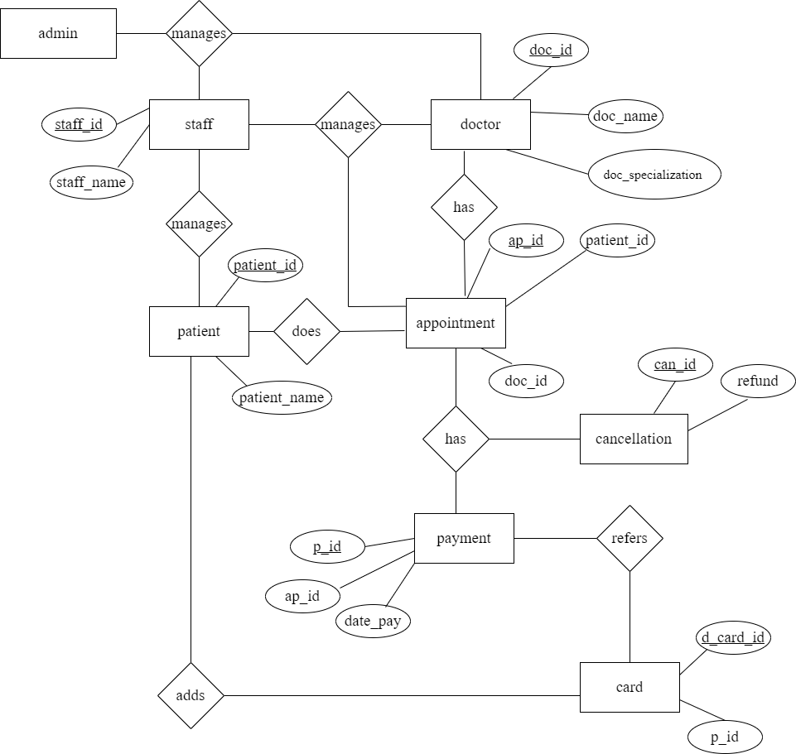

**4.1 INPUT DESIGN**

Input design is the process of converting a user-oriented description of the inputs to a computer-based system into a programmer-oriented specification. The quality of system input determines the quality of system output. Input specification describes how data enter the system for processing. Input design features can ensure the reliability of the system and produce results from accurate data or they can result in the production of errors. The input design also determines whether the user can interact efficiently with the system.

Input design requires consideration of the needs of the data entry operator.

Three data entry considerations are:

* The field length must be documented
* The sequence of fields must match the sequence of the fields on the source document.
* The data format must be identified to the data entry operator.

In our system, almost all inputs are taken from the databases. To provide adequate inputs we have to select necessary values from the databases and arrange them to the appropriate controls.

Inaccurate input data are the most common cause of errors in the data processing. Errors entered by data entry can be controlled by input design. Input design is the process of converting user-oriented inputs to a computer-based format. There are three major approaches to entering data into the computer. They are menus, formatted forms, and prompts. A menu is a selection list that simplifies computer data access or entry. Instead of remembering what to enter, the user choices from the list of options. A formatted form is a pre-printed form or a template that requests the user to enter data in the appropriate location. It is a fill-in-the-blank type form. The form is flashed on the screen as a unit. In prompt the system displays one inquiry at a time, asking the user for a response.

### 

### Homepage

**Description:** This is the Home Page for all the users



**Homepage**

**Description:** About Us Page

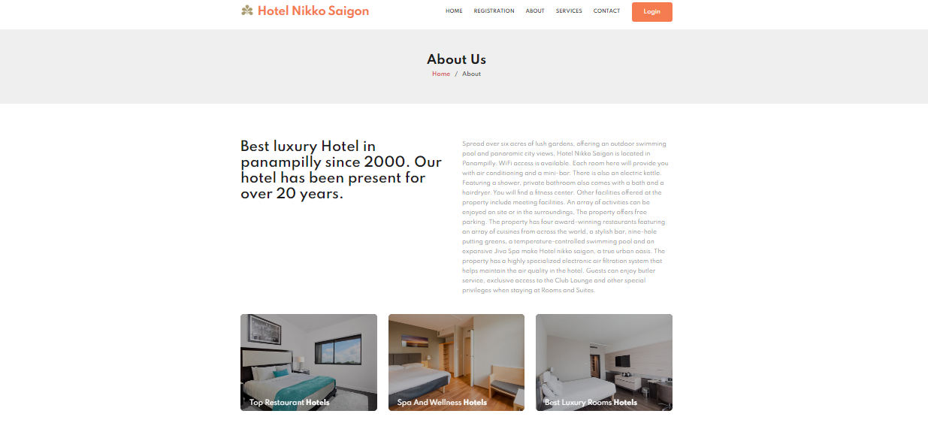

### 

### Login Form

### Description: This is the Login page for all the users

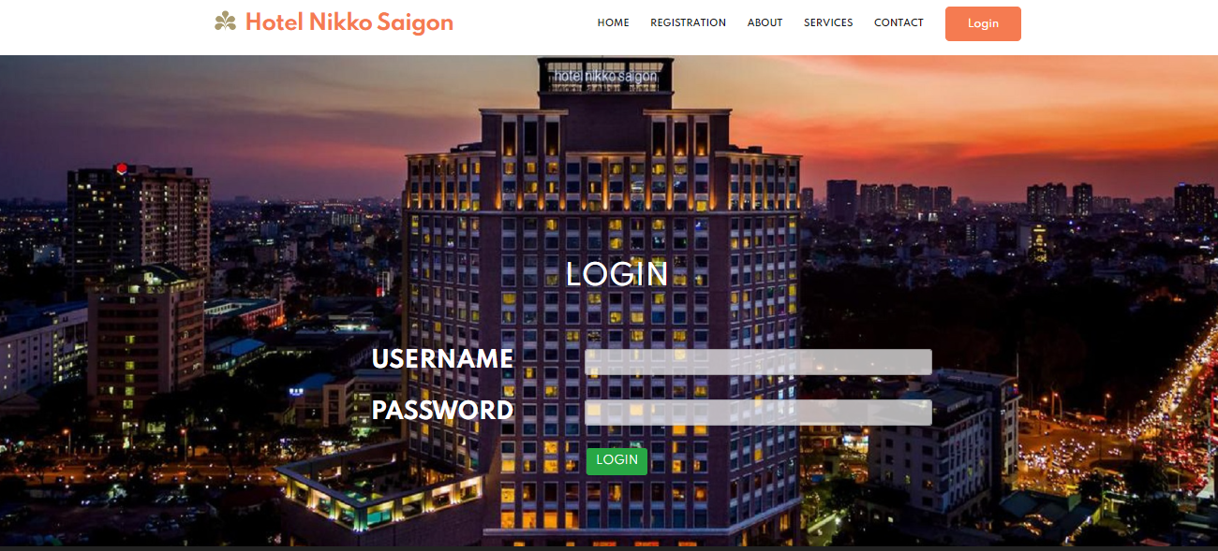

### Patient Registration

**Description:** This form shows the registration page for new patient s

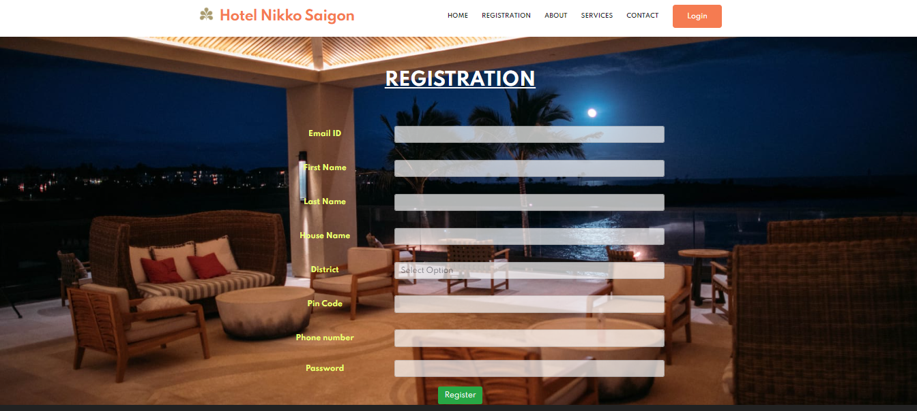

**Staff Page**

**Description:** This form is used by Admin to add new staff page



**Category Page**

**Description:** This form is used to add new category of room



**SubCategory Page**

**Description:** This form is used to add new subcategory of room



**Manage room**

**Description:** This form is used to add new room according to category and subcategory



**Adding category**

**Description:** staff can add new category



**Adding subcategory**

**Description:** staff can add new subcategory



**Availability Page**

**Description:** This form is used to check availability of rooms according to selected dates.

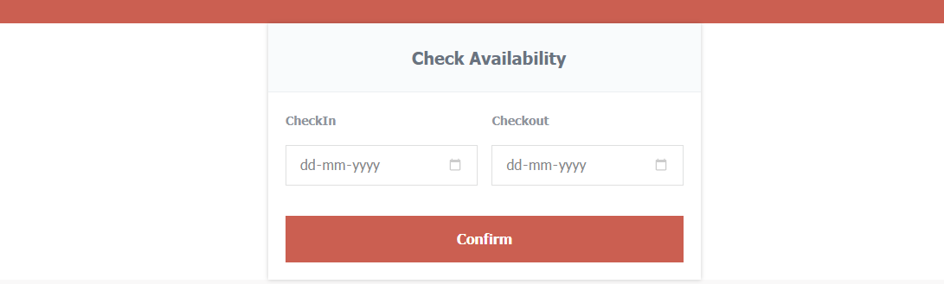

**Booking Page**

**Description:** This form is used for adding room to booking cart

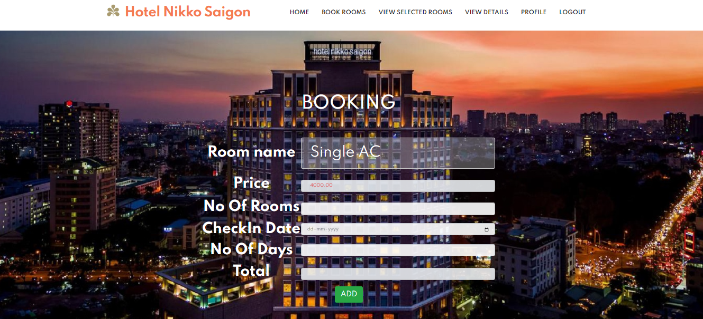

**Payment Page**

**Description:** This form is used for payment for booked rooms by patient

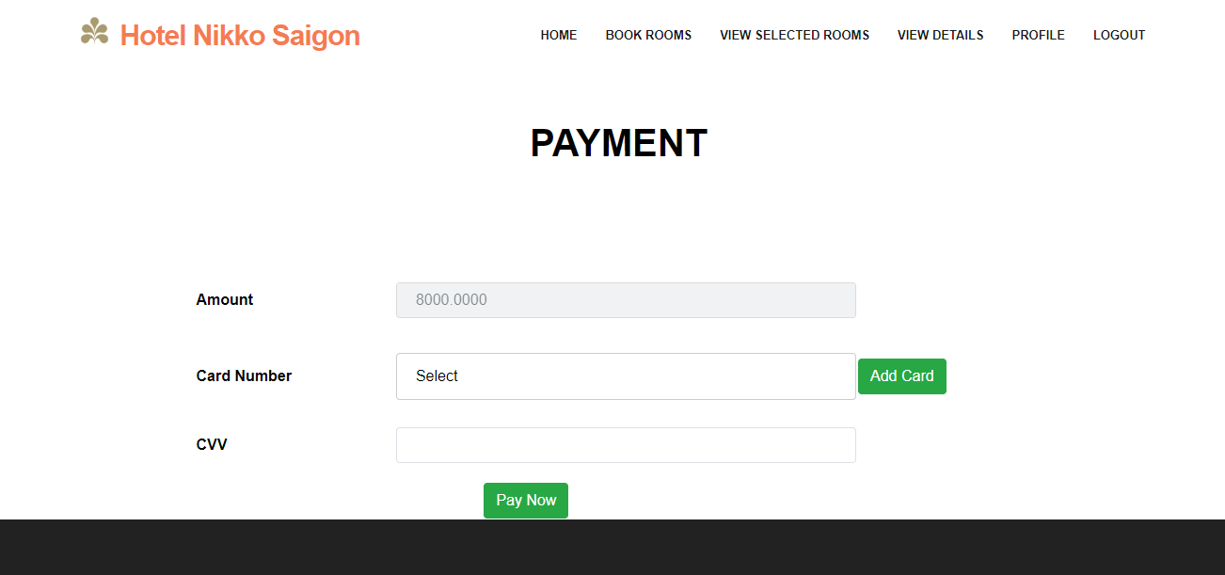

**4.2 OUTPUT DESIGN**

One of the important features of an information system for users is the output it produces. Output is the information delivered to users through the information system. Without quality output, the entire system appears to be unnecessary and users will avoid using it. Uses generally merit the system solely by its output. In order to create the most useful output possible. One works closely with the user through an interactive process, until the result is considered to be satisfactory.

Output design has been an ongoing activity almost from the beginning of the project. In the study phase, outputs were identified and described generally in the project directive. A tentative output medium was then selected and sketches were made for each output. In the feasibility analyis, the “best” new system was selected; its description identified the input and output media. In the design phase, the system has included an evaluation and selection of specific equipment for the system.

Outputs from computer systems are required primarily to communicate the results of processing to the user. They are also used to provide a permanent copy of these results for later consultation.

**Admin page**

**Description:** home page for admin.



**Staff Report**

**Description:** This shows the staff report



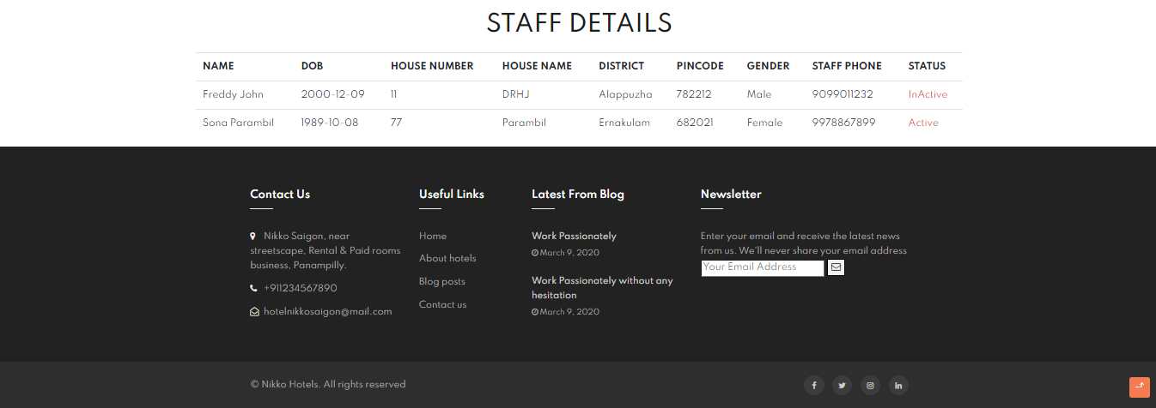

**Patient Report**

**Description:** This shows Patient report on admin page

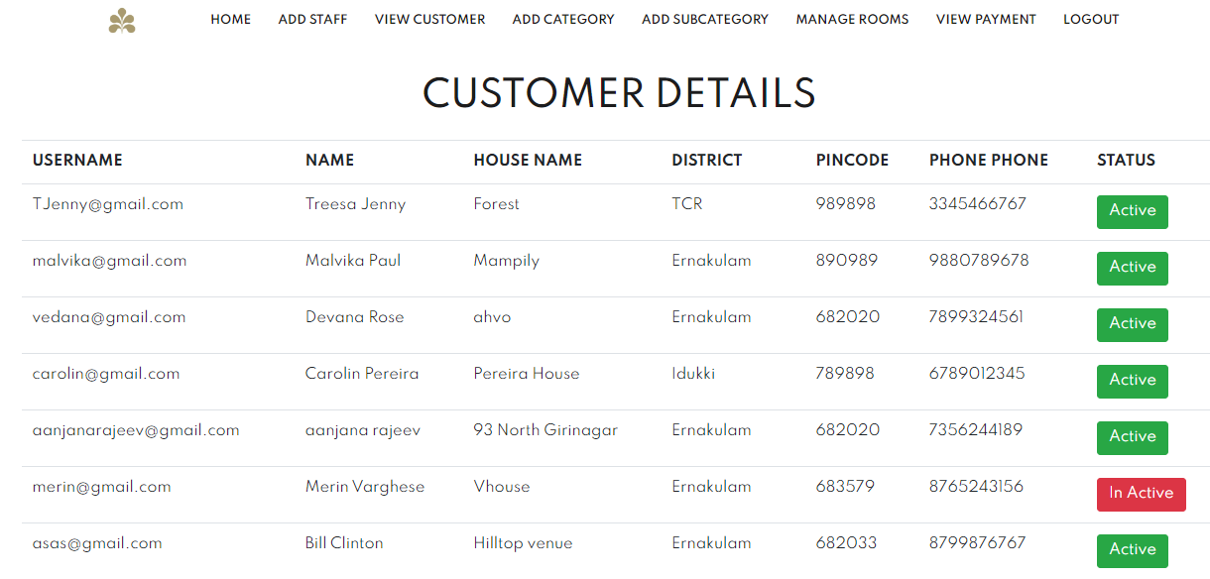

**Room details Report**

**Description:** This shows Room details report

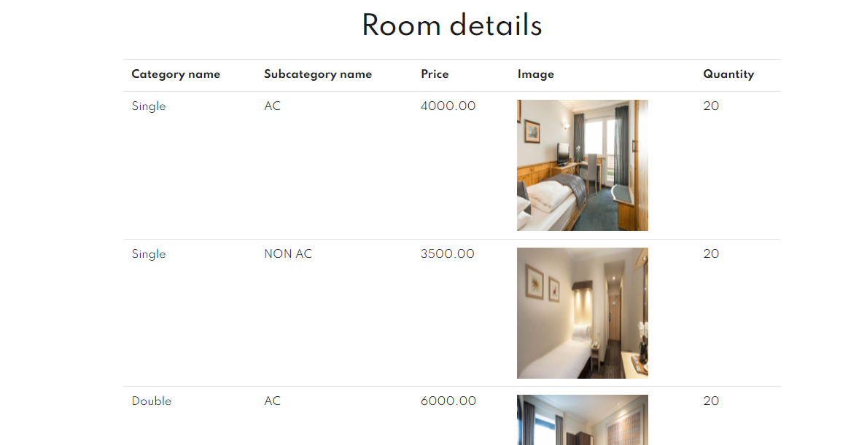

**Room booking**

**Description:** This shows Room booking page on patient ’s page

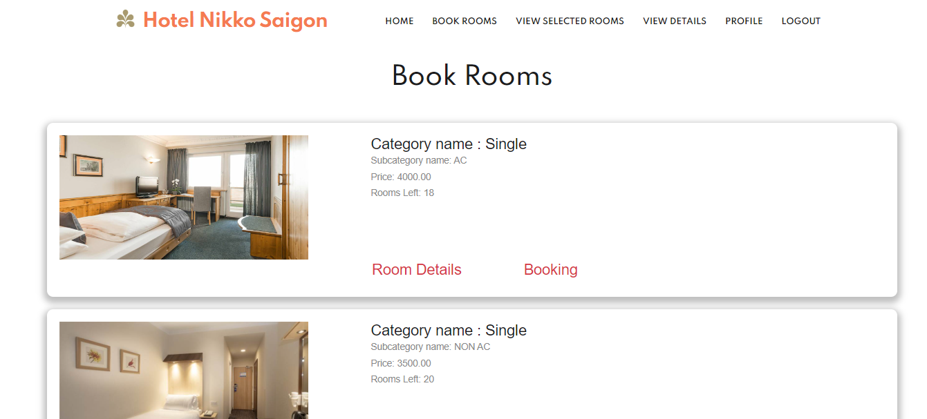

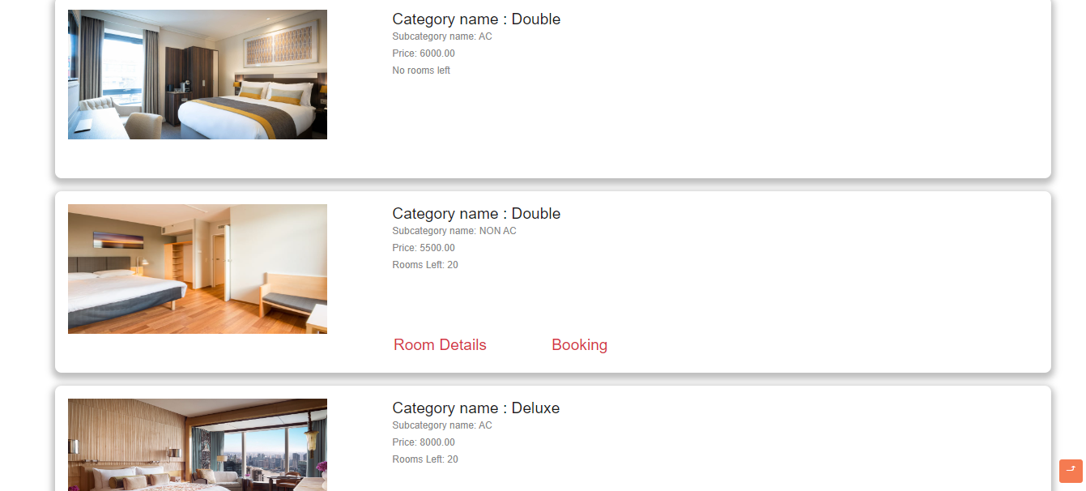

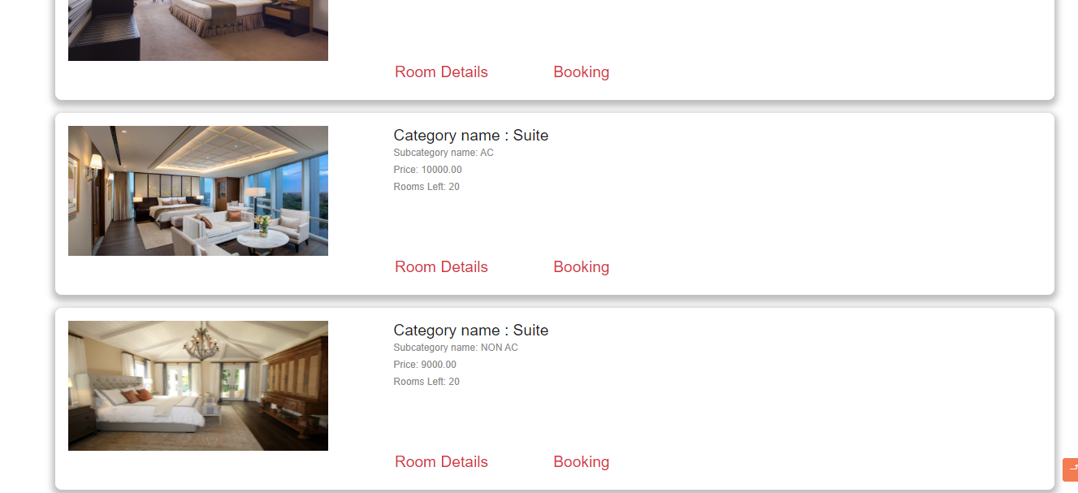

**Booking cart page**

**Description:** This shows the cart page

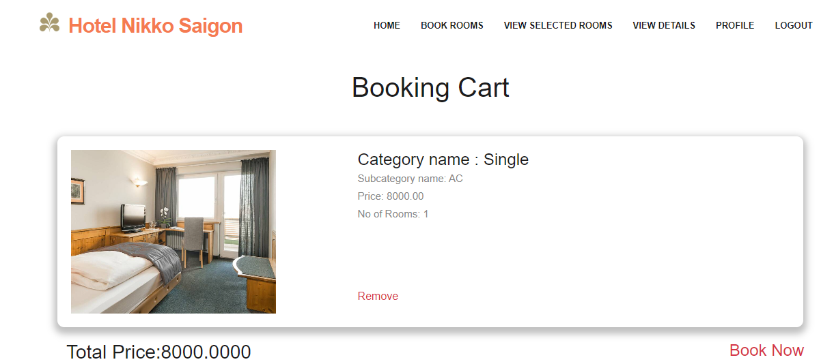

**Staff Page**

**Description:** This shows staff login page



**View Patient**

**Description:** staff can view patient

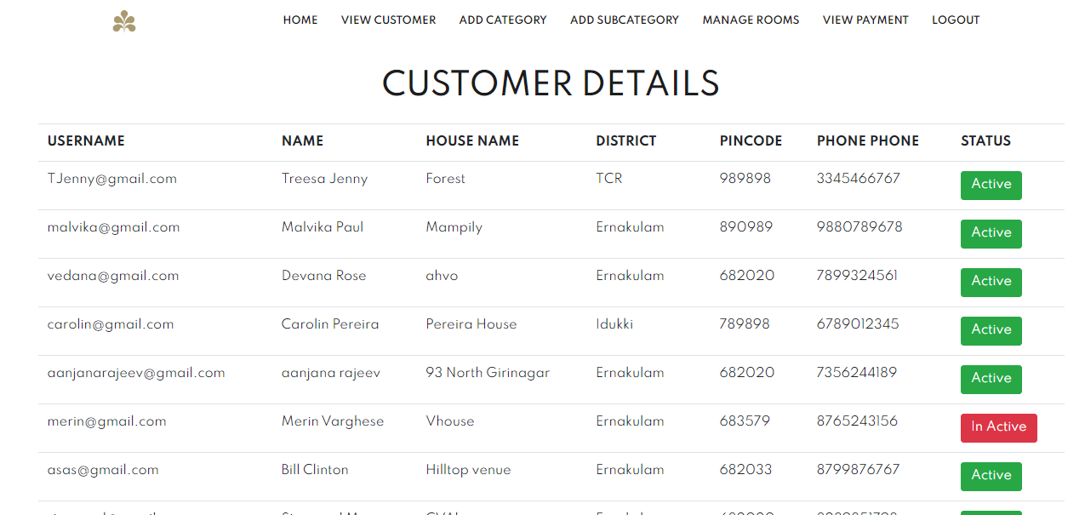

**View payment details**

**Description:** staff can view patient’s payment details

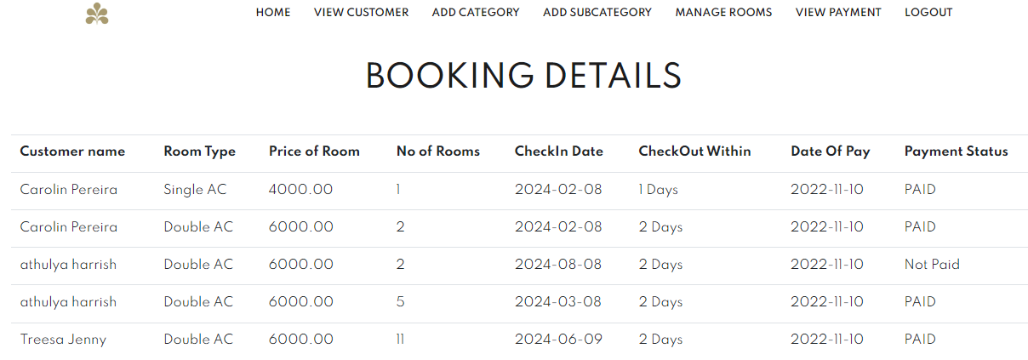

**4.3 DATABASE DESIGN**

**4.3.1 Normalization**

Designing a database is a complex task and the normalization theory is a useful aid in this design process. The process of normalization is concerned with the transformation of the conceptual schema into computer representation form. A bad database design may lead to certain undesirable situations such as:

* Repetition of information
* Inability to represent certain information
* Loss of information

To minimize these anomalies, normalization may be used. If the database is in a normalized form, the data can be restructured and can maintain it easily. This is important that the databases using that we are using may free from data redundancy and inconsistency. For this need we maintain the tables in a normalized manner.

**First Normal Form**

A relation is in first Normal Form (1NF), if and only if all its attributes are based on single domain. The objective of normalizing a table is in to remove its repeating groups and ensure that all entries of the resulting table have at most single value.

**Second Normal Form**

A table is said to be in second Normal Form (2NF), when it is in 1 NF and every attribute in the record is functionally dependent upon the whole key, and not just a part of the key.

**Third Normal Form**

A table is in third Normal Form (3NF), when it is in 2NF and every non-key attribute is functionally dependent on just the primary key.

**TABLE DESIGN**

**Table No 1**

**Table Name:** tbl_login

**Table Description:** stores the login details of existing users in the system.

|  |  |  |  |
| --- | --- | --- | --- |
| **Field** | **Datatype** | **Constraint** | **Description** |
| username | Varchar(25) | Primary key | Login id |
| password | Varchar(10) | Unique | Password |
| usertype | Varchar(6) | Not null | Type of user |

**Table No 2**

**Table Name:** tbl_doctor

**Table Description:** stores details of the doctor.

|  |  |  |  |
| --- | --- | --- | --- |
| **Field** | **Datatype** | **Constraint** | **Description** |
| doc_id | Int(11) | Primary key | Unique ID |
| username | Varchar(25) | Foreign key | Email ID |
| doc_name | Varchar(30) | Not null | Doctor name |
| d_dob | date | Not null | DOB |
| doc_specialization | varchar(15) | Not null | specialization |
| description | Varchar(1000) | Not nul | description |
| st_slot | time | Not null | Doctor’s time slot(starting) |
| et_slot | time | Not null | Doctor’s time slot(ending) |
| fees | Int(3) | Not null | Doctor fees |
| doc_hname | Varchar(20) | Not null | House name |
| doc_district | Varchar(20) | Not null | District |
| doc_pin | Varchar(6) | Not null | Pin code |
| doc_gender | Varchar(6) | Not null | Gender |
| doc_phno | Decimal(10,0) | Not null | Phone number |
| doc_status | Varchar(10) | Not null | Active / Inactive |
| max_p | Int(10) | Not null | Maximum no of patients |
| Image | Varchar(1000) | Not null | Image of doctor |

**Table No 3**

**Table Name:** tbl_staff

**Table Description:** stores the details of staff.

|  |  |  |  |
| --- | --- | --- | --- |
| **Field** | **Datatype** | **Constraint** | **Description** |
| staff_id | int(20) | Primary key | Unique ID |
| username | Varchar(25) | Foreign key | Email ID |
| staff_fname | Varchar(15) | Not null | First name |
| staff_lname | Varchar(15) | Not null | Last name |
| staff_dob | Date | Not null | Date of birth |
| staff_hno | Int(3) | Not null | House number |
| staff_hname | Varchar(20) | Not null | House name |
| staff_district | Varchar(20) | Not null | District |
| staff_pin | Varchar(6) | Not null | Pin code |
| staff_gender | Varchar(6) | Not null | Gender |
| staff_phno | Decimal(10,0) | Not null | Phone number |
| staff_status | Varchar(10) | Not null | Active / Inactive |

**Table No 4**

**Table Name:** tbl_patient

**Table Description:** stores the details of patient

|  |  |  |  |
| --- | --- | --- | --- |
| **Field** | **Datatype** | **Constraint** | **Description** |
| patient_id | int(11) | Primary key | Patient ID |
| username | Varchar(30) | Foreign key | Login Email |
| patient_fname | Varchar(15) | Not null | First Name |
| patient_lname | Varchar(15) | Not null | Last Name |
| p_dob | date | Not null | DOB |
| p_gender | Varchar(6) | Not null | Gender |
| patient_hname | Varchar(50) | Not null | House Name |
| patient_district | Varchar(10) | Not null | District |
| patient_pin | Varchar(6) | Not null | Pin Code |
| patient_phno | Varchar(10) | Not null | Phone Number |
| status | Varchar(10) | Not null | Active/inactive |
| rid | Varchar(30) | Not null | Reference ID |

**Table No 5**

**Table Name:** tbl_appointment

**Table Description:** stores the details of the appointment

|  |  |  |  |
| --- | --- | --- | --- |
| **Field** | **Datatype** | **Constraint** | **Description** |
| ap_id | int(11) | Primary key | Appointment ID |
| patient_id | int(11) | Foreign key | Patient ID |
| doc_id | Int(11) | Foreign key | Doctor ID |
| t_box | Int(10) | Not null | Time slot box |
| adate | date | Not null | Appointment date |
| fees | Int(3) | Foreign key | Doctor fees |
| status | Varchar(7) | Not null | Booked or not |

**Table No 6**

**Table Name:** tbl_payment

**Table Description:** stores the details of payment

|  |  |  |  |
| --- | --- | --- | --- |
| **Field** | **Datatype** | **Constraint** | **Description** |
| p_id | Int(11) | Primary key | Payment ID |
| ap_id | int(11) | Foreign key | Appointment ID |
| d_card_id | Int(11) | Foreign key | Debit card ID |
| date_pay | Date | Not null | Date of Payment |
| p_status | Varchar(10) | Not null | Paid or not |

**Table No 7**

**Table Name:** tbl_card

**Table Description:** stores the details of the card

|  |  |  |  |
| --- | --- | --- | --- |
| **Field** | **Datatype** | **Constraint** | **Description** |
| d_card_id | Int(11) | Primary key | Debit card ID |
| patient_id | Varchar(5) | Foreign key | Patient ID |
| card_no | varchar(16) | Not null | Debit card number |
| card_name | Varchar(25) | Not null | Debit Card Holder name |
| exp_date | Varchar(10) | Not null | Card Expiry date |

**Table No 8**

**Table Name:** tbl_cancel

**Table Description:** stores the details of the appointment cancellation

|  |  |  |  |
| --- | --- | --- | --- |
| **Field** | **Datatype** | **Constraint** | **Description** |
| can_id | Int(11) | Primary key | Cancellation ID |
| p_id | Int(11) | Foreign key | Payment ID |
| refund | Decimal(10,2) | Not null | Refund price |
| bank_name | Varchar(35) | Not null | Bank name |
| bank_branch | Varchar(35) | Not null | Bank branch |

**5.1 INTRODUCTION**

Testing is the process of examining the software to compare the actual behavior with that of the excepted behavior. The major goal of software testing is to demonstrate that faults are not present. In order to achieve this goal, the tester executes the program with the intent of finding errors. Though testing cannot show the absence of errors by not showing their presence it is considered that these are not present.

System testing is the first stage of implementation, which is aimed at ensuring that the system works accurately and efficiently before live operations commence. Testing is vital to the success of the system. System testing makes a logical assumption that if all the parts of the system are correct and the goal will be successfully achieved. A series of testing are performed for the proposed system before the proposed system is ready for user acceptance testing.

**Levels of Testing**

5.1.1 Unit testing

5.1.2 Integration testing

5.1.3 Validation testing

5.1.4 Output testing

5.1.5 User Acceptance Testing

**5.1.1 Unit testing**

In this, each module is tested individually before integrating it into the final system. Unit test fopatientes verification in the smallest unit of software design in each module. This is also known as module testing as here each module is tested to check whether it is producing the desired output and to see if any error occurs.

**5.1.2 Integration testing**

Integration testing (sometimes called integration and testing, abbreviated I&T) is the phase in software testing in which individual software modules are combined and tested as a group. It occurs after unit testing and before validation testing.

Integration testing takes as its input modules that have been unit tested, groups them in larger aggregates, applies tests defined in an integration test plan to those aggregates, and delivers as its output the integrated system ready for system testing. The purpose of integration testing is to verify the functional, performance, and reliability requirements placed on major design items.

**5.1.3 Output testing**

No system could be useful if it does not produce the required output in the specific format. Output testing is performed to ensure the correctness of the output and its format. The output generated or displayed by the system is tested by asking the users about the format required by them.

**5.1.4 Validation testing**

In software project management, software testing, and software engineering, validation is the process of checking that a software system meets specifications and that it fulfills its intended purpose. The errors which are uncovered during integration testing are connected during this phase.

**5.1.5 User Acceptance Testing**

The system under consideration is tested for user acceptance by constantly keeping in touch with the prospective system user at the time of development. The testing of the software began along with the coding. Unit testing was done for each module in the software. For various inputs such that each line of code is executed at least once.

**6.1 INTRODUCTION**

Implementation is the stage in the project where theoretical design is turned into a working system and is giving confidence in the new system for the users which will work efficiently and effectively. It involves careful planning, investigation of the current system and its constraints on implementations, design of methods to achieve the changeover, and evaluation, of changeover methods. Apart from planning major tasks of preparing the implementation are education and training of users. The major complex system being implemented the more evolved will be the system analysis and the design effort required just for implementation. An implementation coordination committee based on the policies of individual organisations has been appointed. The implementation process begins with preparing a plan for the implementation of the system. According to this plan the activities are to be carried out dispatientsions made regarding the equipment and resources and the additional equipment has to be acquired to implement the new system.

Implementation is the final and important phase. The most critical stage in achieving a successful new system and in giving the users confidence that the new system and in giving the users confidence that the new system will work and be effective. The system can be implemented only after thorough testing is done and if found to working according to the specification.

**6.2 INSTALLATION PROCEDURE**

Installation of software refers to the final installation of the package in the real environment, to the satisfaction of the intended users and the successful operation of the system. In many organizations, those who commission software development projects will not be the ones to operate them. In the initial stage, the person who is not sure that the software will make the jobs easier will doubt about the software.

Implementation is the stage of the project where the theoretical design is turned into a working system. At this stage, the main workload, the greatest upheaval, and the major impact on the existing system shift to the user department. If the implementation is not carefully planned and controlled, it can cause confusion.

Implementation includes all those activities that take place to convert from the old system to the new one. Proper implementation is essential to provide a reliable system to meet organizational requirements. Successful implementation may guarantee improvement in the organization using the new system, but improper installation will prevent it. The process of putting the developed system into actual use is called system implementation.

**6.3 IMPLEMENTATION PLAN**

The Implementation plan describes how the information system will be deployed, installed, and transitioned into an operational system. The plan contains an overview of the system, a brief description of the major tasks involved in the implementation, the overall resources needed to support the implementation effort, and any site-specific implementation requirements. The plan is developed during the Design Phase and is updated during the Development Phase the final version is provided in the Integration and Test Phase and is used for guidance during the Implementation Phase.

Implementation is the most crucial stage in achieving a successful system and for us, it is the process of bringing the “Online Eye Hospital Management System” into operational use and training it over to the user. Implementation includes all those activities that take place to convert from the old system to the new one. The basic requirements for implementing the proposed system are already mentioned above. This software provides total security for operations. That is, it prevents any unauthorized access. After successful login, the user can go to the form according to the situation

**7.1 FUTURE ENHANCEMENT**

The system has been developed with flexibility in mind. The requirement of the company is bound to change as and when new operations are included. Keeping in view advancements that are being made in technology it is necessary that the system be able to cope with the changes that are bound to happen.

So, in today's world of mobile technology the software “Online Eye Hospital Management System” if integrated with the mobile will be an added advantage. Mobile users will get instant alerts from this site. The software if we create a mobile app or an alert system for more interaction with the user and also widening the reach of the system to its users.

Though the new system provides a base for improving the efficiency of operations, there are a lot of future enhancements that can be added to this project. Keeping this in view, a provision has been made in the system to facilitate easy modification updating in the future. Any modification will not affect the normal working of the system.

The development system is very interactive, coded in such a way as to ensure maximum user-friendliness, and also allows flexibility for the future.

It can be extended in such a way that:

• Improve security.

• Improve performance.

**BIBLIOGRAPHY**

**Textbooks**

The following textbooks are also referred to the building of this project.

* + - * Fundamental of Database System – Ramez Elmasri and Sham Kand P Nayadha
      * Web Programming Using PHP – Binu M. B and Amaladevi V. C

**Website References**

The following websites are referred to create this project report.

* [www.stackoverflow.com](http://www.stackoverflow.com)
* <https://www.w3schools.com/js/js_validation.asp>
* https://www.geeksforgeeks.org
* https://www.javatpoint.com/form-validation-in-php

**APPENDICES**

**APPENDIX A**

Sample Source Code/Pseudo Code

**Patient Registration code**

**Login code**

**APPENDIX B**

Acronyms

ER- Entity relation

SQL- Structured Query Language

DFD- Data Flow Diagram

1NF- First Normal Form

2NF- Second Normal Form

3NF- Third Normal Form